Date: 02/05/2025

Name: Geethika R

**AUTOMATION PROJECT**

GOAL

---------

This program verifies whether the user is able to browse through different options available in the igp.com website and choose a product of interest, personalize it and add it to the cart.

1. Open IGP.com website, which is a site that allows the user to send gifts to his/her person of choice
2. Block the undesired Chrome notifications
3. Perform login validation using data driven method where values are fetched from an external Excel document
4. Here the data is fetched from an external excel sheet - IgpLoginData.xlsx with 5 input entries
5. Login validation is successful after fetching the correct Email ID and password from the provided Excel document
6. User can now browse through different options available in the website and verify the selections
7. User clicks on ‘Personalized’ option in the homepage to personalize the gift
8. User clicks on ‘Occasions’ tab and choose ‘Birthday Gifts’ from the dropdown
9. User clicks on ‘Same Day Delivery’ tab and choose ‘Gifts for Her’ from the dropdown
10. User clicks on ‘Recipients’ tab and choose ‘Her’ from the dropdown
11. User clicks on ‘Photo Gifts’ tab and choose ‘Photo Frames’ from the dropdown
12. User clicks on ‘Name Gifts’ tab and choose ‘Name Print Diaries & Pen’ from the dropdown
13. User clicks on delivery location pincode entering area from the top of the webpage
14. A window appears in which the user enters the pincode and click on ‘Apply’ button
15. User clicks on a product of his/her choice - “Matte Elegance Personalized Gel Pen”
16. Scrolls Down
17. User chooses a required delivery date of the product from the calendar.
18. Click on ‘Personalize Now’ button
19. A window appears, and the user enters a required personalization message in the textbox provided
20. Click on Save
21. Click on Save and Review button, allowing the user to review the personalized message on the product selected
22. Click on ‘Add to Cart’ button
23. Click on ‘Continue without Addons’ button
24. This takes the user to Shopping Cart Page
25. Click on ‘Proceed to Checkout’ button
26. Take a screenshot of the webpage that appears next to take a note of upcoming steps to be done.
27. User goes back to the previous webpage
28. User clicks on profile icon
29. User clicks on ‘Sign Out’ option from the dropdown

PROGRAM

----------------

1. IGP Base Class → IgpBaseClass.java

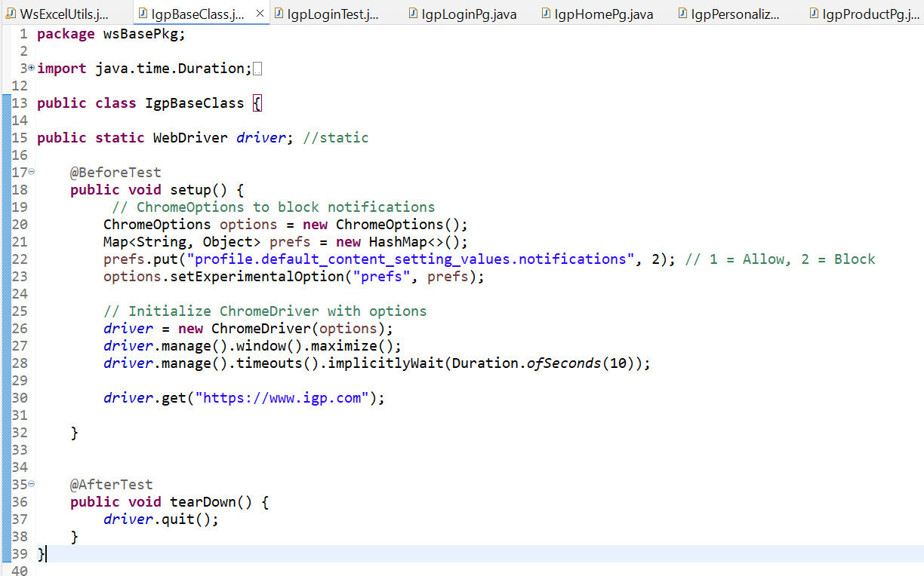

1. IGP Login Page → IgpLoginPg.java

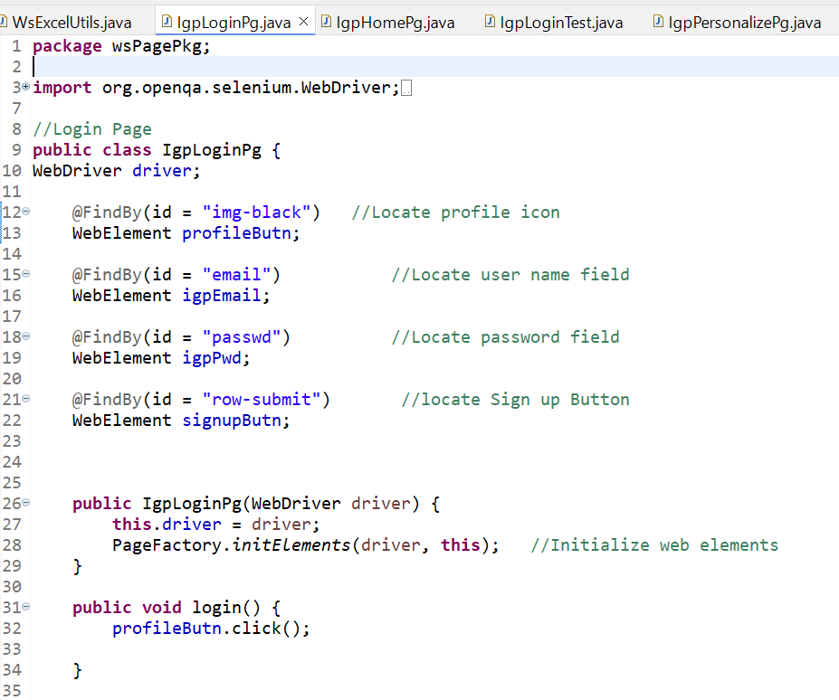

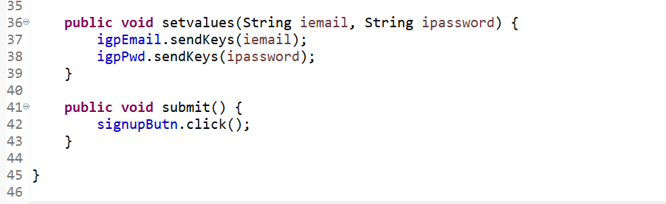

1. IGP Home page → IgpHomePg.java

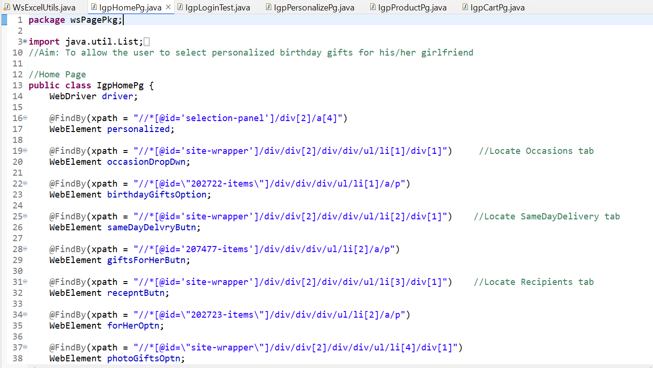

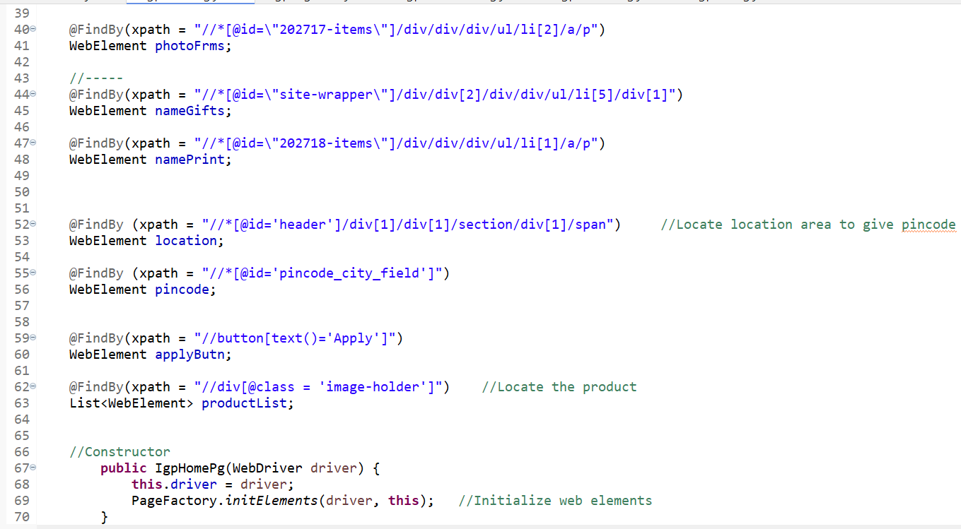

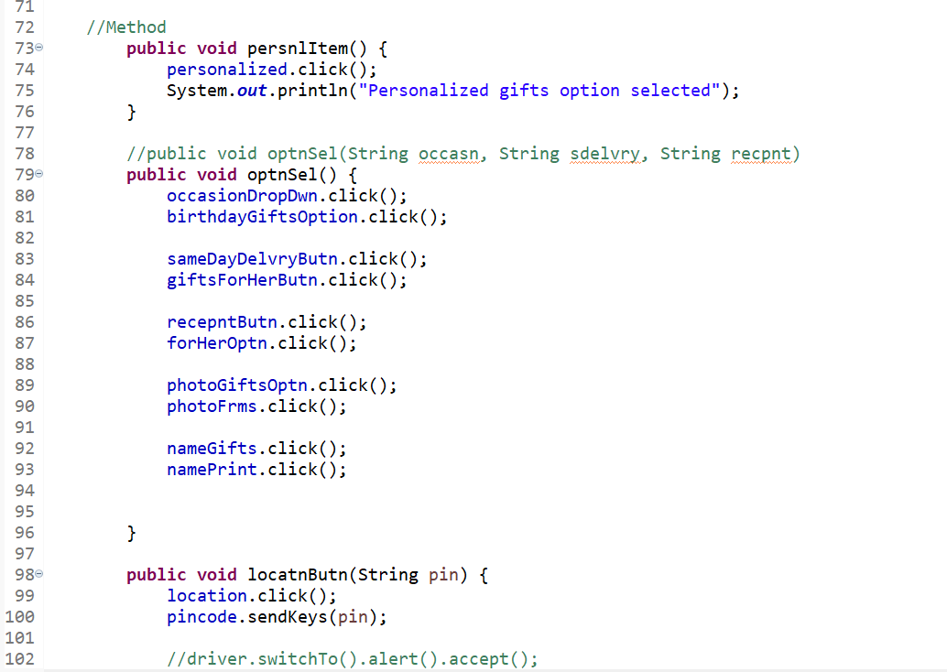

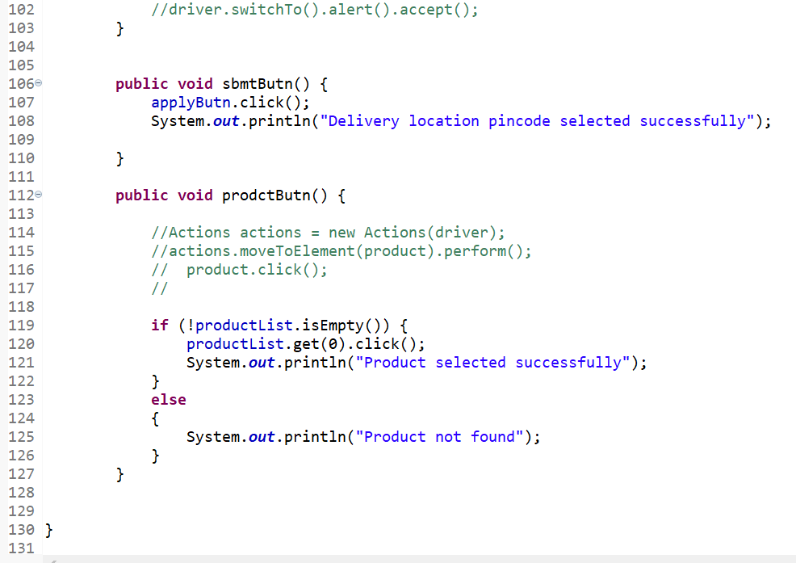

1. IGP Product Page —> IgpProductPg.java

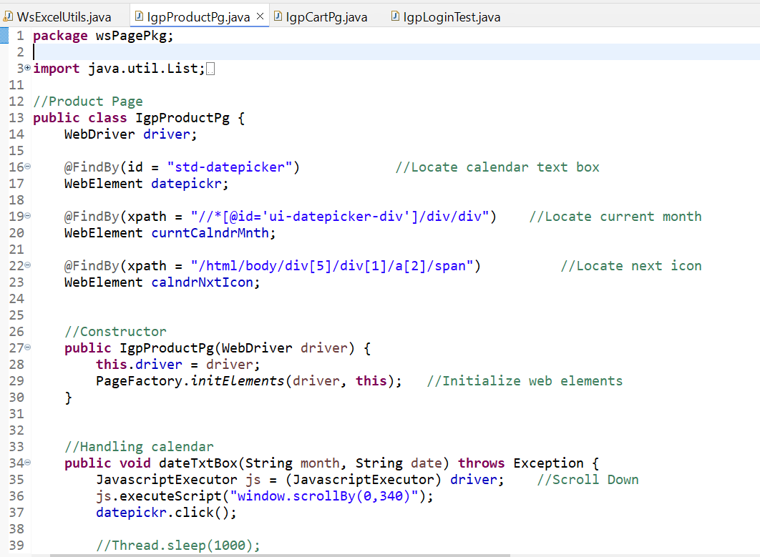

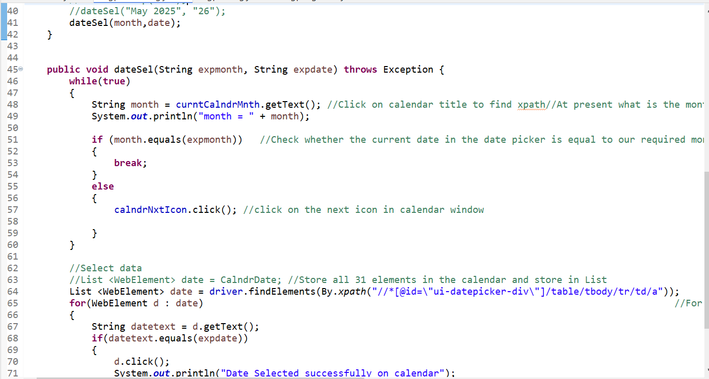

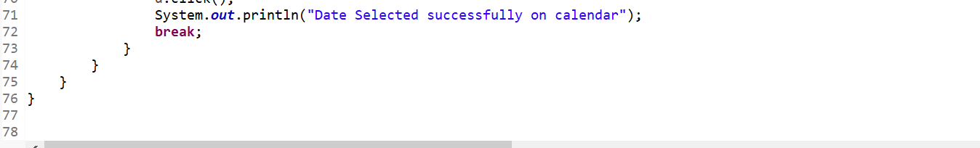

1. IGP Personalization Page —> IgpPersonalizePg.java

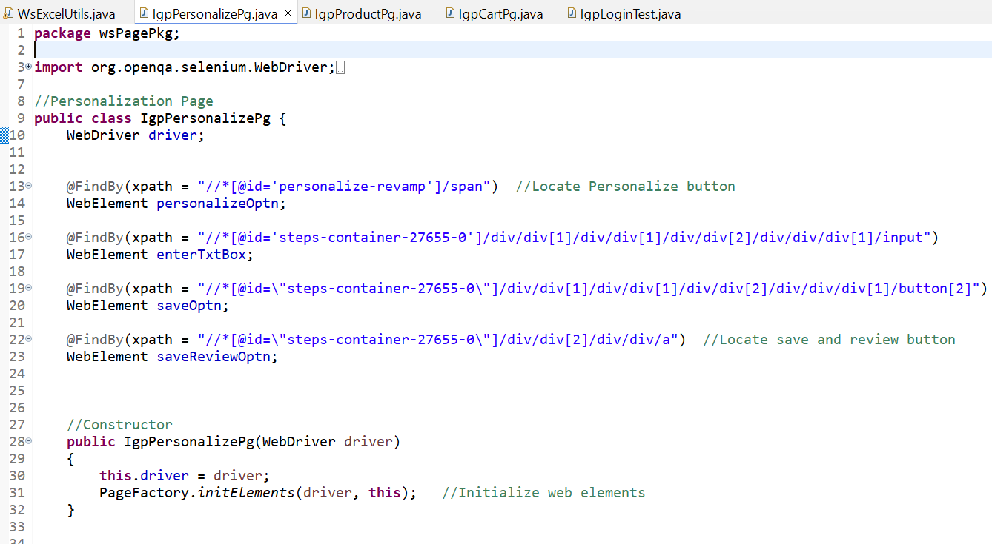

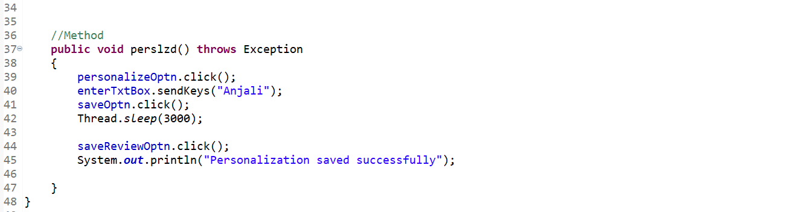

1. IGP Cart Page → IgpCartPg.java

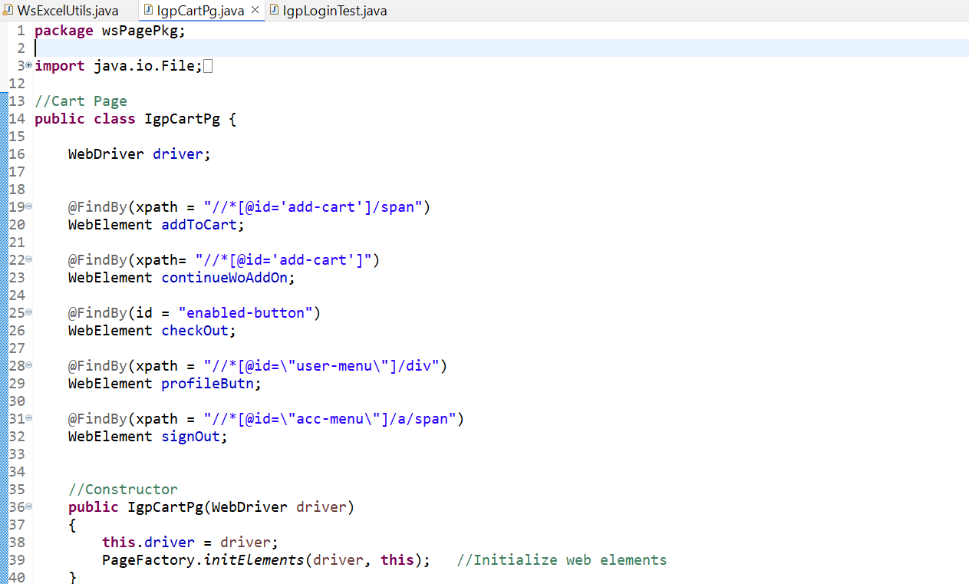

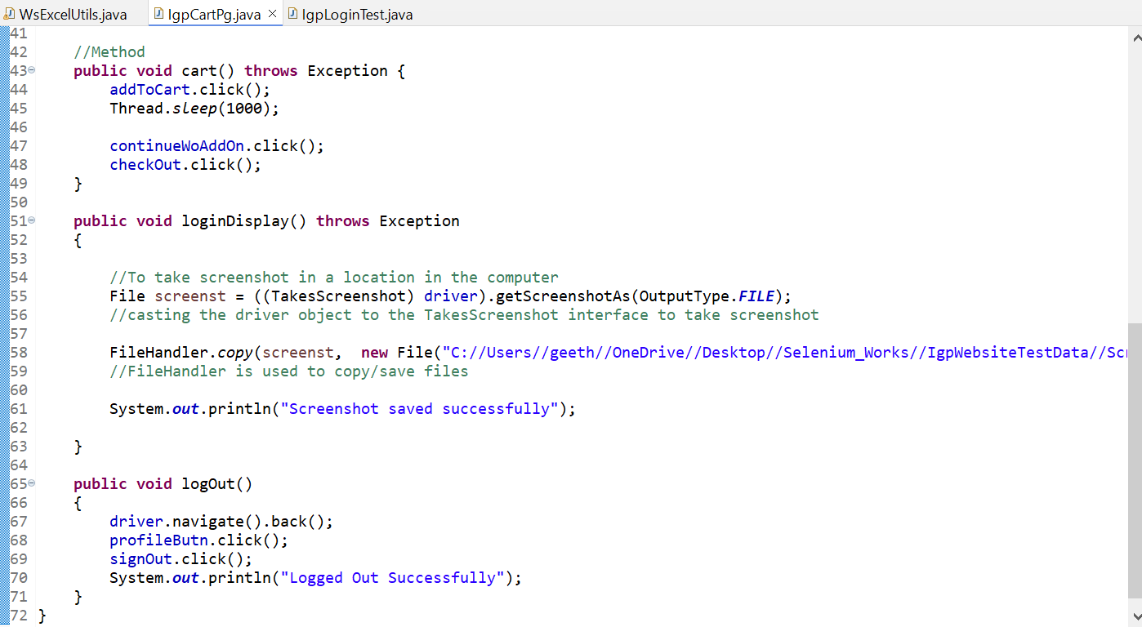

Path where screenshot is saved: "C://Users//geeth//OneDrive//Desktop//Selenium_Works//IgpWebsiteTestData//ScrnshotImg.png"

7.IGP ExcelUtils Page → WsExcelUtils.java

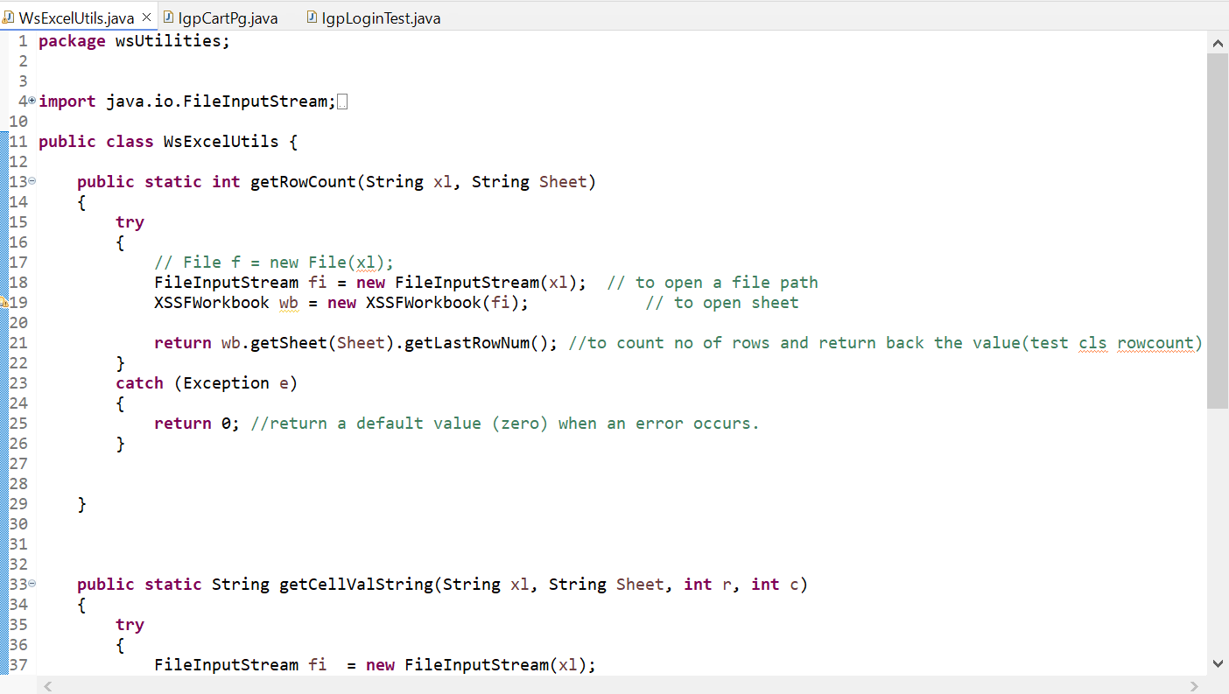

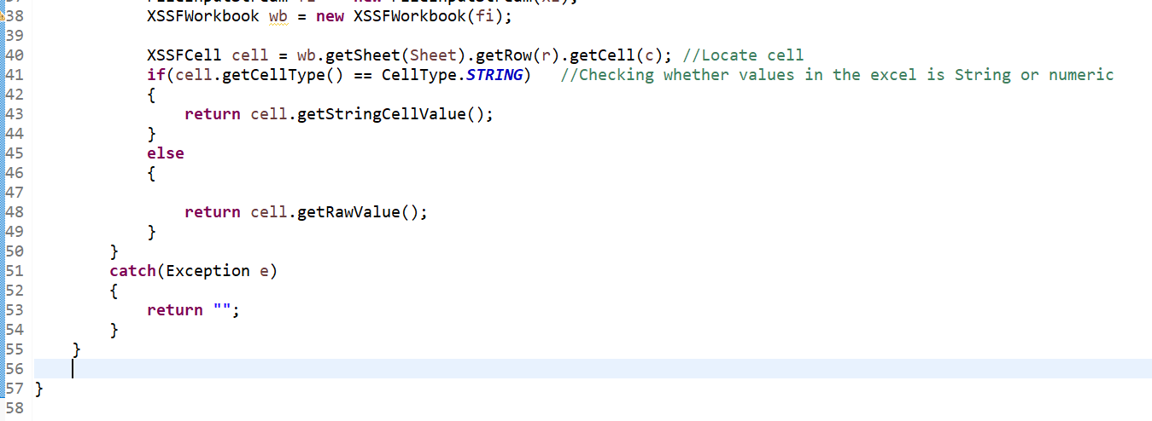

8. IGP Login Test

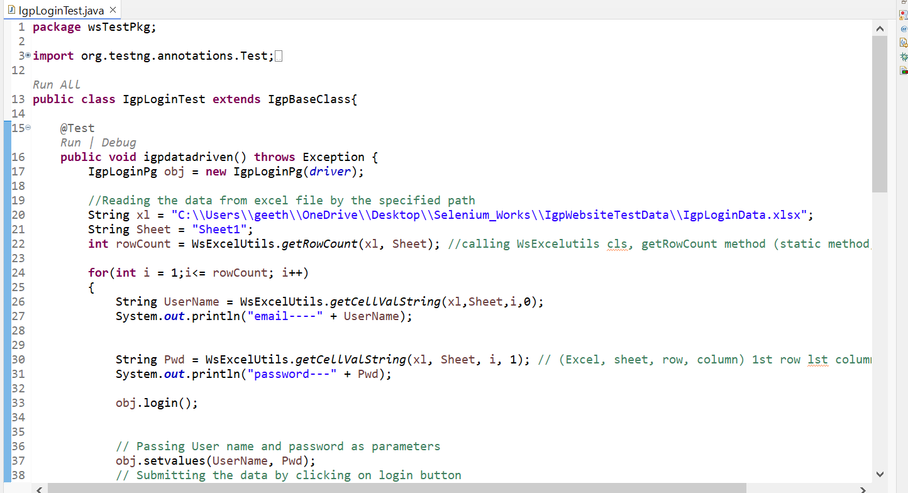

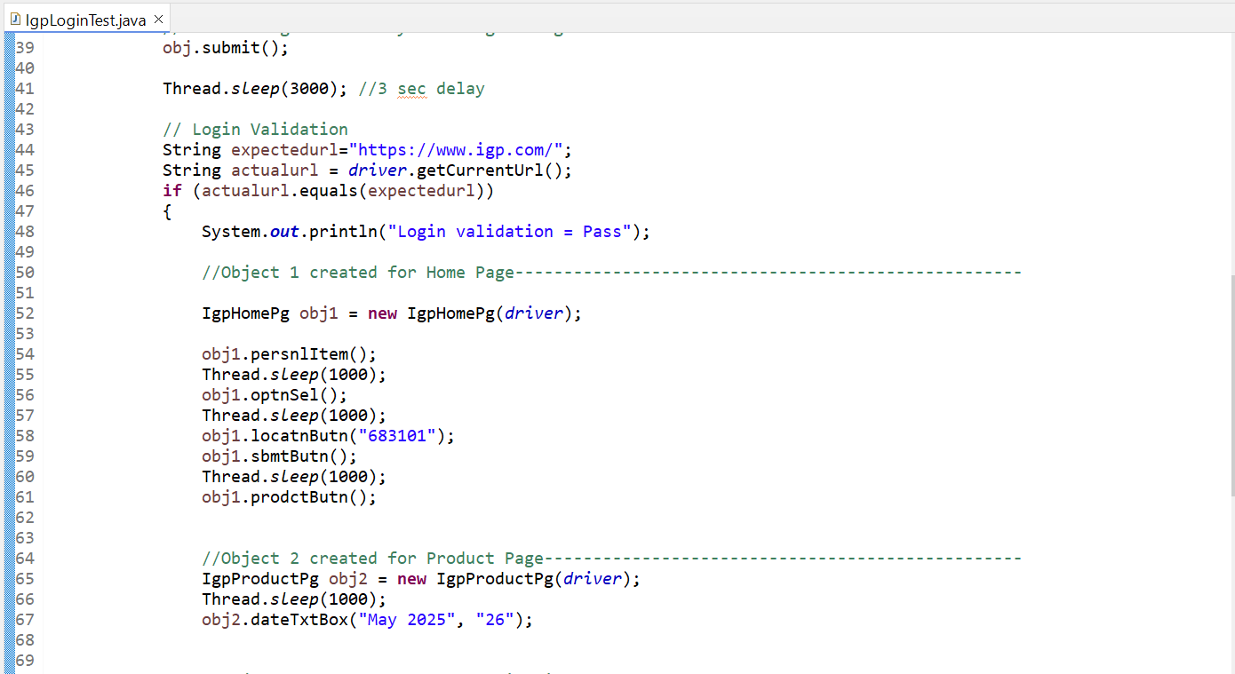

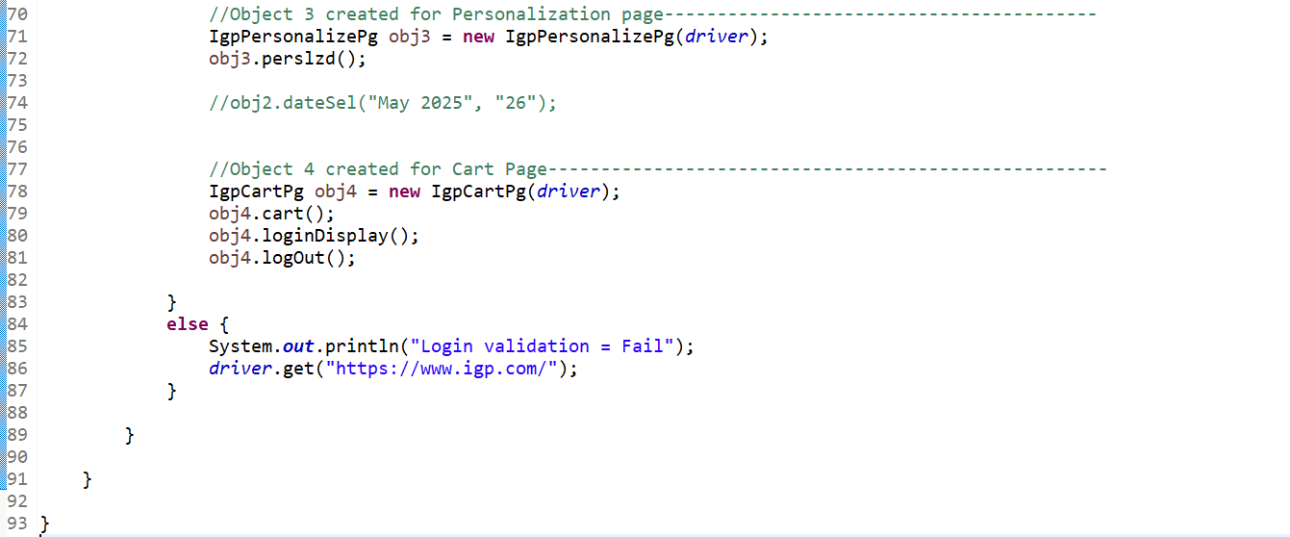

Files:

--------

Generated screenshot file

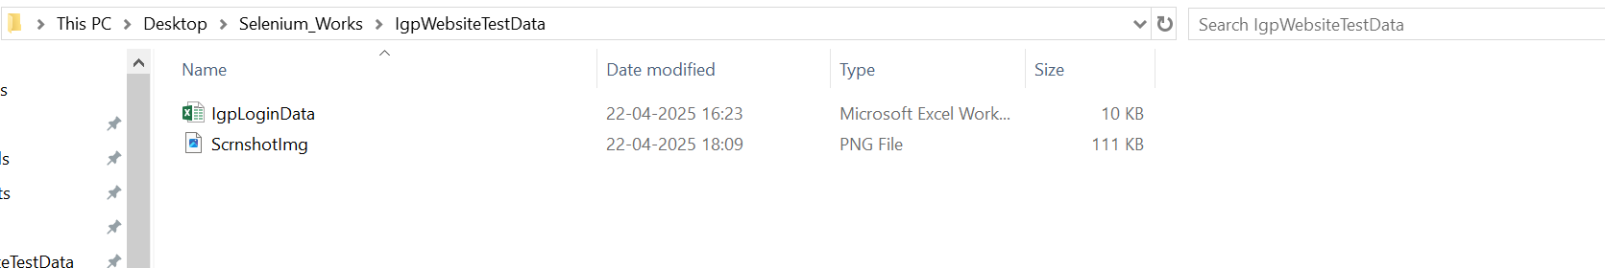

IgpLoginData → Excel file data:

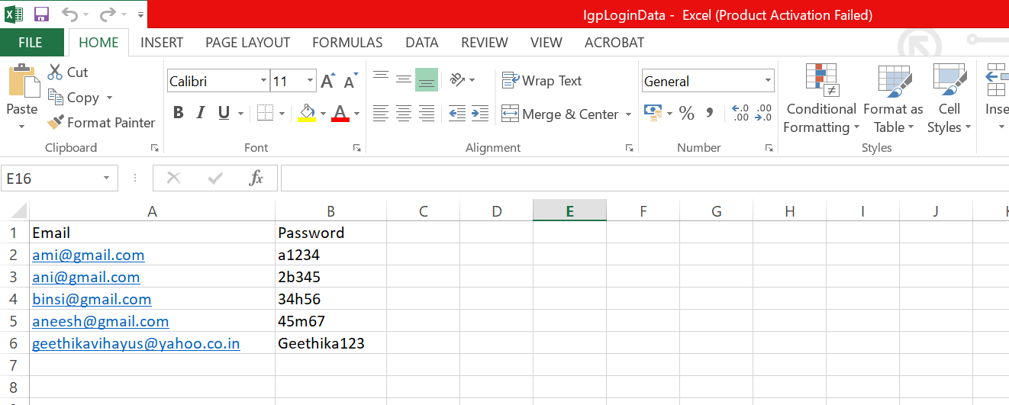

File Structure

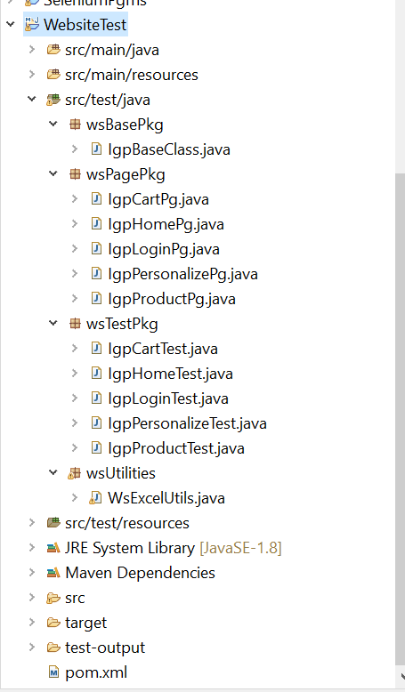

Pom.xml file:

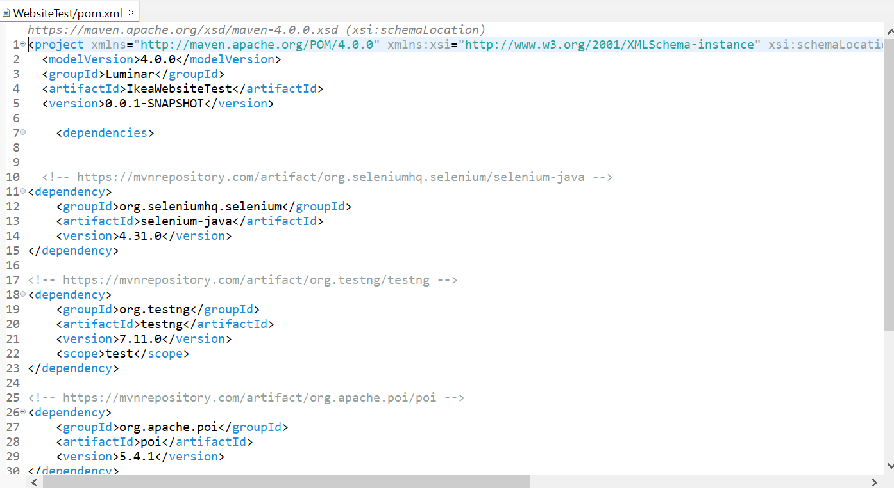

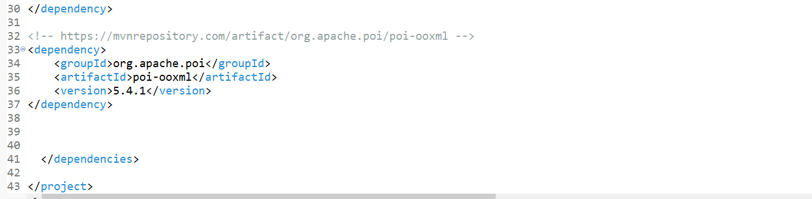

**OUTPUT**

**--------------**

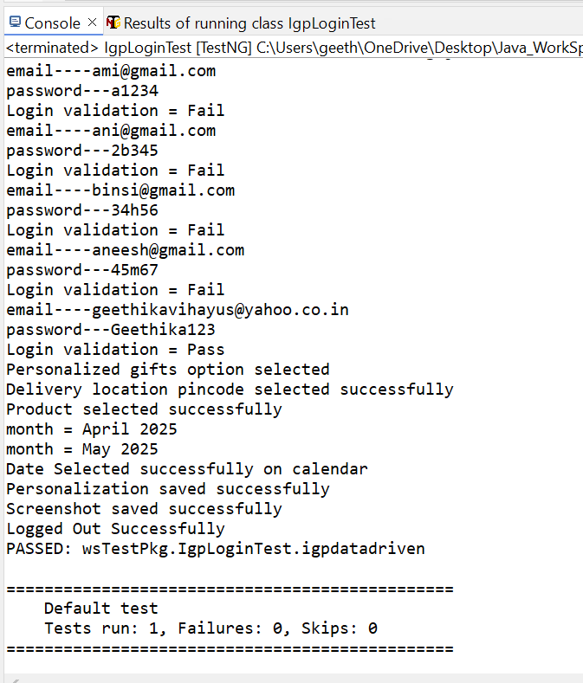

Concepts used in Automation Testing using igp.com website

---------------------------------------------------------------------------------

Main ones are listed below:

- TestNG with Maven

- POM design pattern using Page factory

- Data driven test using external Excel sheet inputs

- Xpath

- Xpath using contains

- Dropdown handling

- Calendar updation

- Usage of Scroll down

- Usage of Browser’s Back button

- Thread.sleep

- Usage of ImplicitWait

- Saving Screenshot

Note: Run the project from IgpLoginTest.java file